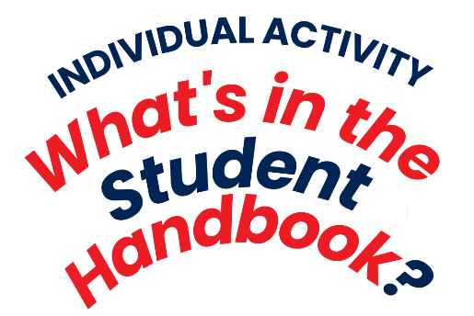
Name: Earl Cedric C. Relunia
Course and Section:VE CIS102
Date of Submission: sep 10 2026
Reflection Guide Questions:
- Is the offense and the corresponding sanction or disciplinary action reasonable?
For me, Yes. I firmly agree that the punishment sustained by the perpetrator is reasonable and justifiable.
- What is your personal stand on the offense? Does it really have to be considered an offense? Why or why not?

- What could be an effective and efficient way to implement policies related to the offense?
Chosen offenses:
Major offenses:
- Section 1.1: Any form of cheating in assessment activities or graded course works whether in-class or off-class for the purpose of improving one’s academic standing.
Reflection Guide Questions:
- Is the offense and the corresponding sanction or disciplinary action reasonable?
For me, Yes. I firmly agree that the punishment sustained by the perpetrator is reasonable and justifiable.
- What is your personal stand on the offense? Does it really have to be considered an offense? Why or why not?
Yes, it absolutely indubitably considered an offense, cheating is an academic skip of achievement, students are expected to learn and are tested with what they learnt, simply skipping these defeats the purpose of academic achievements.

- What could be an effective and efficient way to implement policies related to the offense?
An effective way to implement these policies is by strictly regulating a teacher’s response and countermeasures to cheating, to prevent, or catch cheaters.

- Section 2.1: Threatens to physically assault/ injure or actual physical assault/ injury committed against any member or visitors of the Mapúa MCL academic community.
Reflection Guide Questions:
- Is the offense and the corresponding sanction or disciplinary action reasonable?
For me, Yes. I firmly agree that the punishment sustained by the perpetrator is reasonable and justifiable.
- What is your personal stand on the offense? Does it really have to be considered an offense? Why or why not?
This is an absolute must, for me, the punishment is justified. This is an offense as this threatens an individual’s sense of safety.
- What could be an effective and efficient way to implement policies related to the offense?
We can effectively implement policies related to this offense by standardized de escalation methods, or providing hotlines or easy access to report offenders.

Minor offenses:
- Section 1: Disrupting or disturbing classes or making excessive noise within Mapúa MCL premises.
Reflection Guide Questions:
- Is the offense and the corresponding sanction or disciplinary action reasonable?
For me, Yes. I firmly agree that the punishment sustained by the perpetrator is reasonable and justifiable.
- What is your personal stand on the offense? Does it really have to be considered an offense? Why or why not?
This is justified as disrupting the class not only affects the professor and the offender but also the entire class’ ability to learn efficiently and also wastes everyone’s time.
- What could be an effective and efficient way to implement policies related to the offense?
We can openly demarcate or draw the line between public social hubs and study zones depending on the individual’s specific need.

- Section 12: disrespect for Mapúa MCL symbols or 12 national symbols;
Reflection Guide Questions:
- Is the offense and the corresponding sanction or disciplinary action reasonable?
For me, Yes. I firmly agree that the punishment sustained by the perpetrator is reasonable and justifiable.
- What is your personal stand on the offense? Does it really have to be considered an offense? Why or why not?
The school reserves its right to respect and dignity, while it may not be human like individuals, it as a higher education is still entitled to basic respect as it embodies shared academic values; as It represents an entire community of students, faculty, and staff.
- What could be an effective and efficient way to implement policies related to the offense?
One idea I have is allowing students or any faculty member to report outright offensive/slanderous exposition against MMCL. This offense is highly subjective as shallow remarks such as meme or jokes may still infer disrespect to the institution, so it’s best to investigate the matter or question the individual for their motive and peacefully talk to them.

